Photography A Level
Portfolio for application without previously studying GCSE Art, Photography or Media at GCSE.
If you have not taken a GCSE in either Photography, Art or Media, you MUST complete this task and show us on Enrolment Day. Please choose one of the following photographers as an influence and then do a shoot (approx. 20-30 images) in the style of that photographer. Once you have chosen your photographer please complete the questions on the next page. We will ask you about these questions at enrolment and about your creative choices.
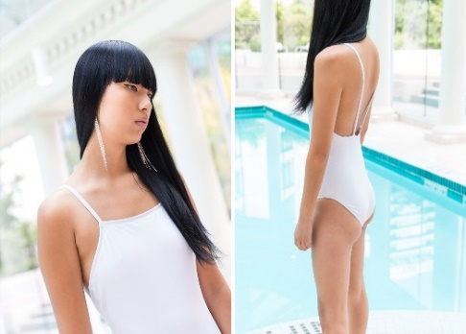
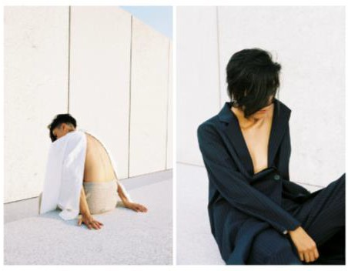
Christina Paik - Urban fashion photographer
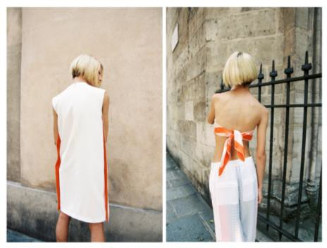
Ronya Galka – Street documentary photographer
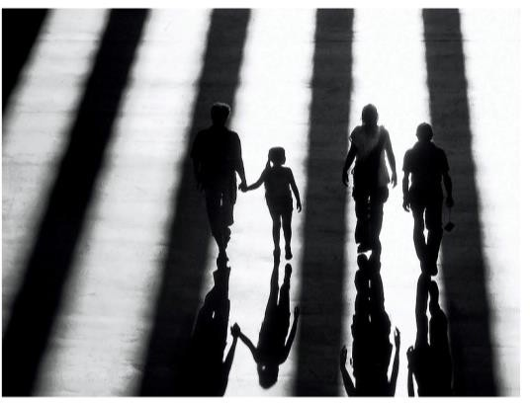
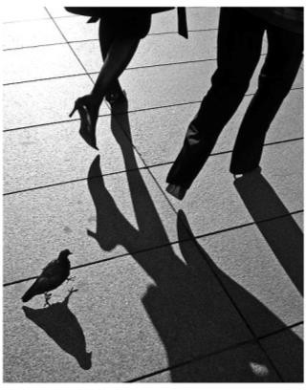
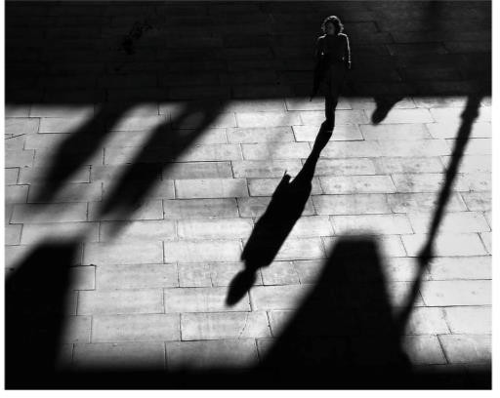
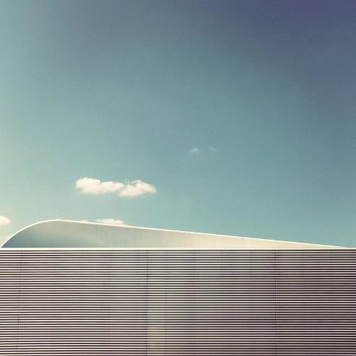
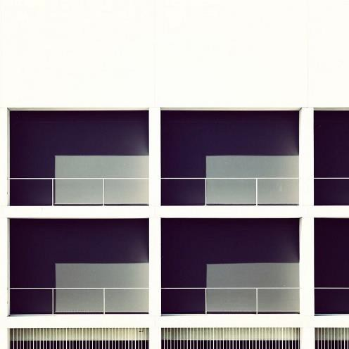
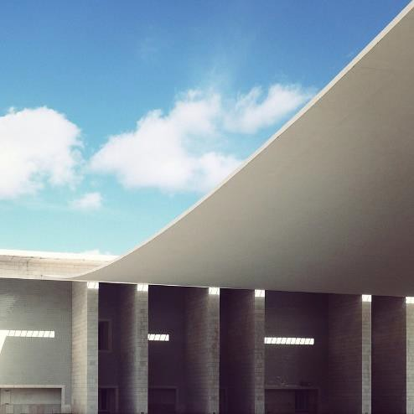
Sebastien Weiss’s Lines series – Architectural photographer

Photography Task Write Up
Before you shoot complete questions 1 and 2, after you shoot complete the rest.

Which Photographer did you choose and why?

- What are three words you would use to describe their work?

- Explain your thought process – what did you plan to shoot to emulate the photographers work and why?

- What did you use to take the photos? Did you edit them at all?

- What mood would you describe the images as having?

- How would you improve your shoot?

